Test Case: tc003_SPX_Dev5_Crear_Requisicion_Spot_Tipo_Cobro_CC_Urgent
Step 1 - Enter username and password and click to button Enter : Credentials Entered
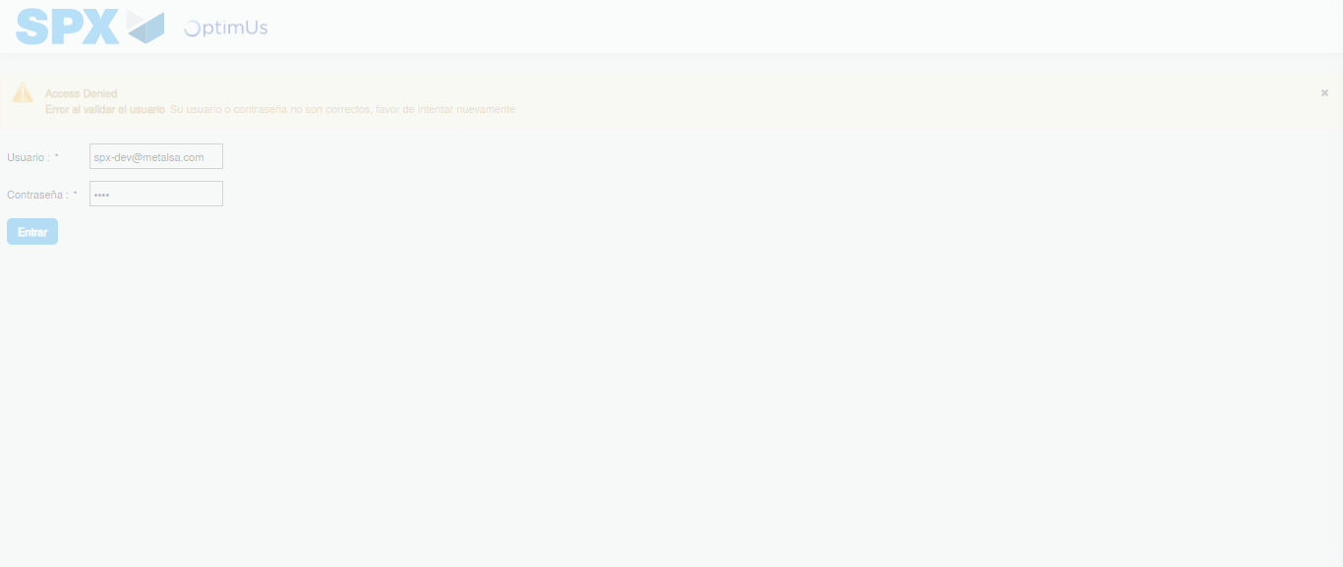Image file-name: QC_Testing-tc003_SPX_Dev5_Crear_Requisicion_Spot_Tipo_Cobro_CC_Urgent-1782240066906

Step 2 - Select to UEN and Access to Spot Buy Requisitions : UEN Correctly selected and Correct access
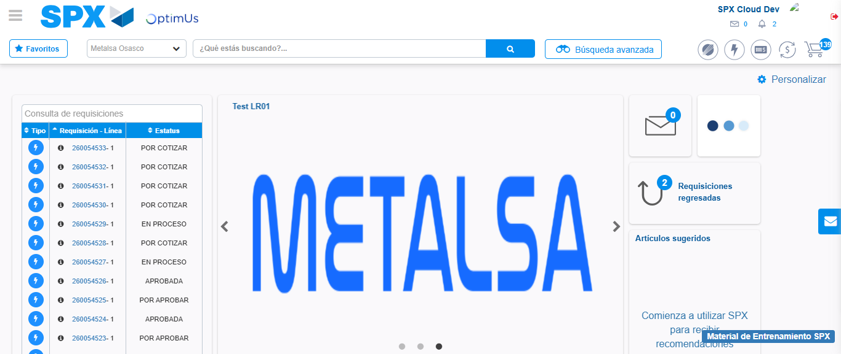Image file-name: QC_Testing-tc003_SPX_Dev5_Crear_Requisicion_Spot_Tipo_Cobro_CC_Urgent-1782240092895

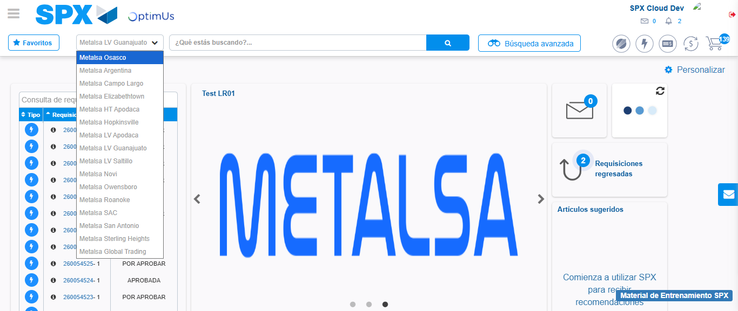Image file-name: QC_Testing-tc003_SPX_Dev5_Crear_Requisicion_Spot_Tipo_Cobro_CC_Urgent-1782240095479

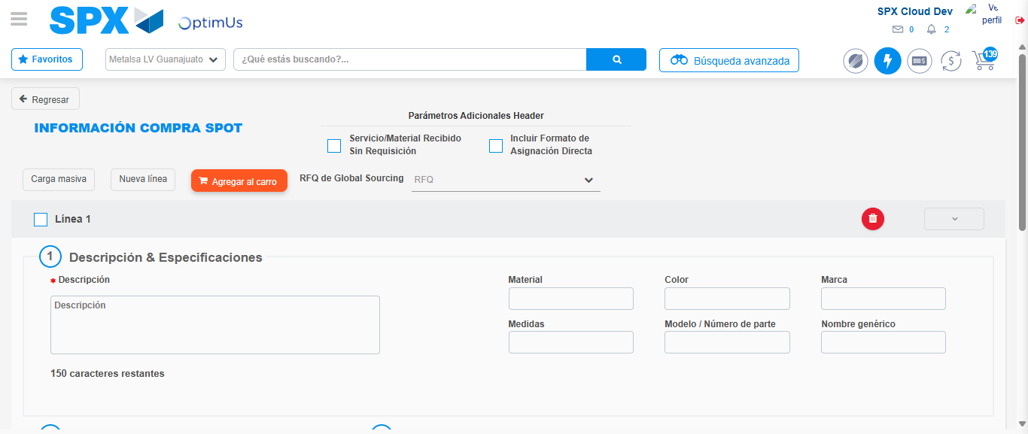Image file-name: QC_Testing-tc003_SPX_Dev5_Crear_Requisicion_Spot_Tipo_Cobro_CC_Urgent-1782240123703

Step 3 - Data Capture Spot Buy Requisition: Data captured correctly
Image file-name: QC_Testing-tc003_SPX_Dev5_Crear_Requisicion_Spot_Tipo_Cobro_CC_Urgent-1782240123916

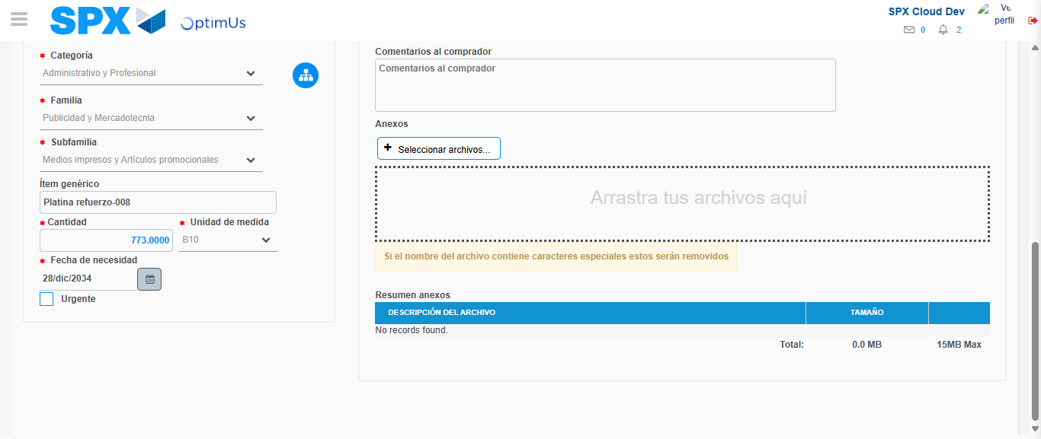Image file-name: QC_Testing-tc003_SPX_Dev5_Crear_Requisicion_Spot_Tipo_Cobro_CC_Urgent-1782240134149

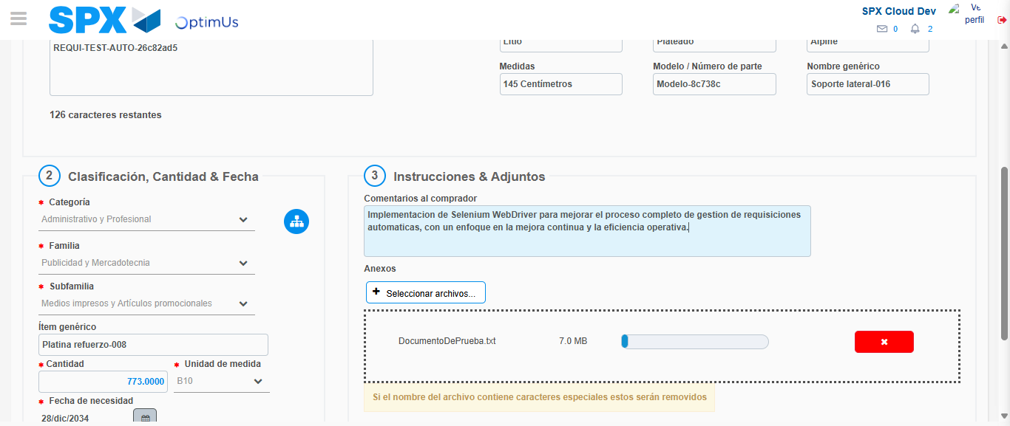Image file-name: QC_Testing-tc003_SPX_Dev5_Crear_Requisicion_Spot_Tipo_Cobro_CC_Urgent-1782240134895

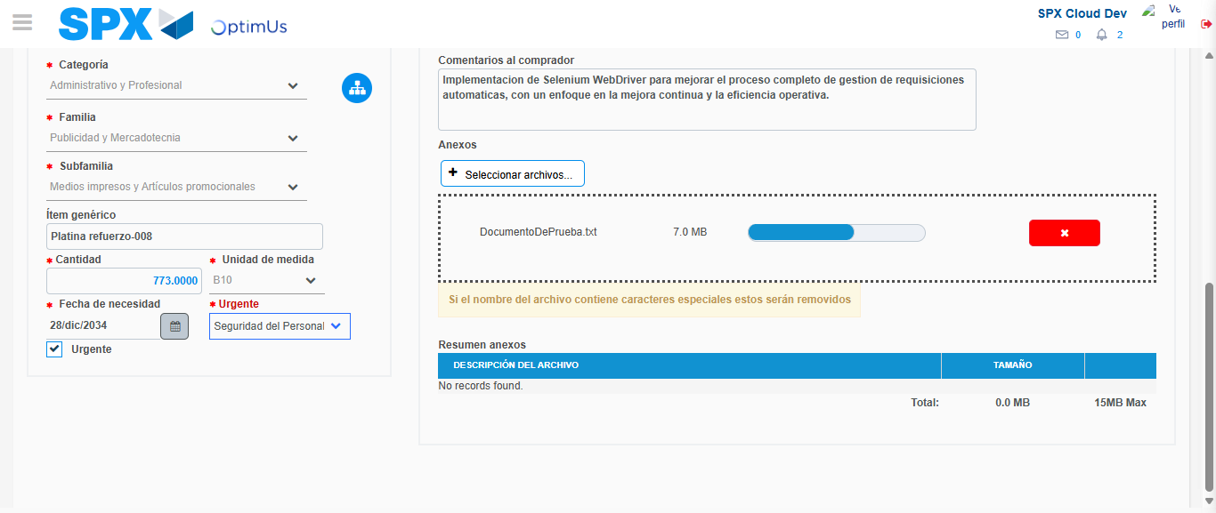Image file-name: QC_Testing-tc003_SPX_Dev5_Crear_Requisicion_Spot_Tipo_Cobro_CC_Urgent-1782240138494

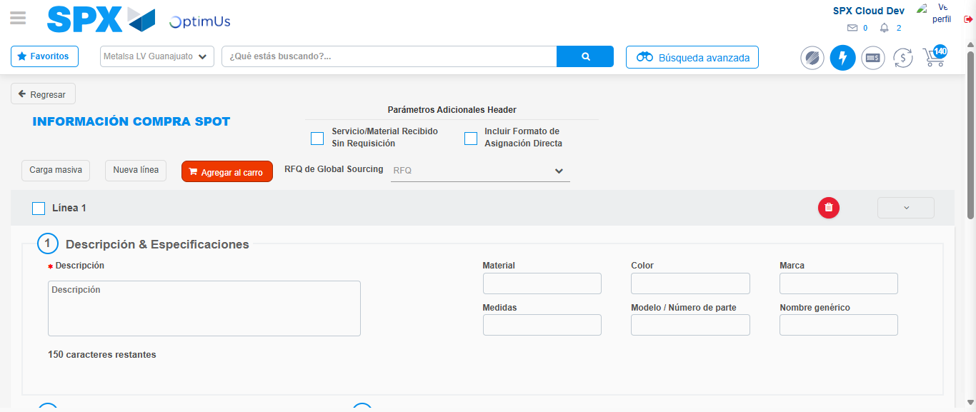Image file-name: QC_Testing-tc003_SPX_Dev5_Crear_Requisicion_Spot_Tipo_Cobro_CC_Urgent-1782240149477

Step 7 - Return to Main Page SPX : Return to Main Page SPX
Image file-name: QC_Testing-tc003_SPX_Dev5_Crear_Requisicion_Spot_Tipo_Cobro_CC_Urgent-1782240092895

Image file-name: QC_Testing-tc003_SPX_Dev5_Crear_Requisicion_Spot_Tipo_Cobro_CC_Urgent-1782240095479

Image file-name: QC_Testing-tc003_SPX_Dev5_Crear_Requisicion_Spot_Tipo_Cobro_CC_Urgent-1782240123703

Image file-name: QC_Testing-tc003_SPX_Dev5_Crear_Requisicion_Spot_Tipo_Cobro_CC_Urgent-1782240151702

Image file-name: QC_Testing-tc003_SPX_Dev5_Crear_Requisicion_Spot_Tipo_Cobro_CC_Urgent-1782240151885

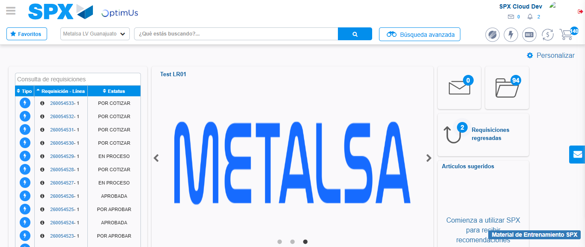Image file-name: QC_Testing-tc003_SPX_Dev5_Crear_Requisicion_Spot_Tipo_Cobro_CC_Urgent-1782240173064

Step 8 - Log Out : Log Out SPX
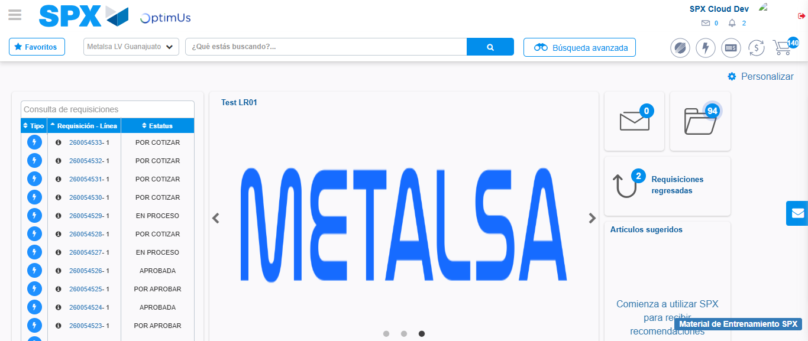Image file-name: QC_Testing-tc003_SPX_Dev5_Crear_Requisicion_Spot_Tipo_Cobro_CC_Urgent-1782240173313

